EXPERIMENT N0-6 S.KAVIN SAINATH 231901018

DATE: 29/8/2024

Customize Switch with Network Modules using Cisco Packet Tracer

**1. Open Cisco Packet Tracer**

● Launch Cisco Packet Tracer on your computer.

# Add a Switch to Your Workspace

* In the device toolbar (usually on the left side of the screen), locate the "Switches" section.
* Drag and drop a switch model onto the workspace. For instance, you might choose a model like the "2950" or "2960."

# Access the Switch’s Physical Layout

* Click on the switch in the workspace to open its configuration window.
* Navigate to the "Physical" tab to see the switch's physical layout and modules.

# Add Network Modules

* In the "Physical" tab, you might see options to add or modify network modules.
* Click on the slot where you want to add a module. You can choose from available modules such as different types of Ethernet or Fiber modules.
* Drag the module from the list of available modules and drop it into the slot on the switch.

# Configure the Modules

* After adding the module, switch to the "Config" tab in the switch’s configuration window.
* Here, you can configure the ports provided by the module. For example, you can set IP addresses, VLAN configurations, and other settings for the new interfaces.

# Configure the Switch Ports

* Switch to the "Config" tab to configure ports on the switch. Here, you can set parameters for each port.
* Select the specific port or range of ports you want to configure. You can set parameters such as VLAN assignments, port descriptions, and more.
* For example:

○ To configure a port to be in a specific VLAN:

■ Select the port or range of ports.

■ Assign the VLAN ID under the VLAN settings.

○ To set a description for the port:

■ Enter a description in the "Description" field.

# Using the CLI for Detailed Configuration

* Switch to the "CLI" tab for command-line interface access.
* Enter configuration commands to set up the switch. Here’s an example of how to configure VLANs and interface settings via CLI:

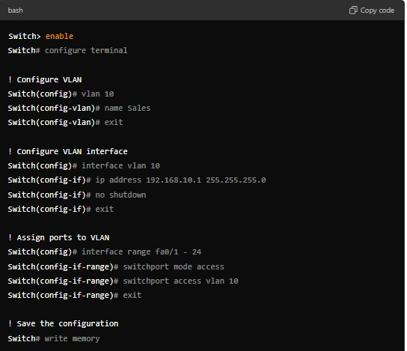

# Save Your Configuration

● Once you’ve configured the modules and ports, be sure to save your configuration.

Use commands in the CLI (Command Line Interface) if you’re using a model that supports CLI commands.

For example:

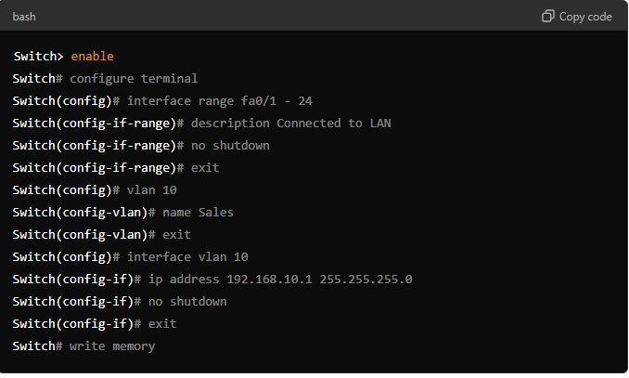

# Test Your Configuration

* Use the simulation mode to test the network configuration.
* Add devices (PCs, routers, etc.) and connect them to the switch to ensure that everything is working as expected.

You tube link:

1. <https://www.youtube.com/watch?v=y2PnZG83gp4>
2. <https://www.youtube.com/watch?v=ZMC1YJB8CLs>
3. [https://www.youtube.com/watch?v=7dXBN8a-X2U&list=PLRjPlu6MAom4KJiAekYPO 85igy-uGYFzW](https://www.youtube.com/watch?v=7dXBN8a-X2U&list=PLRjPlu6MAom4KJiAekYPO85igy-uGYFzW)

OUTPUT:-

RESULT:-

Switch with network modules using cisco packet tracer is customized.

